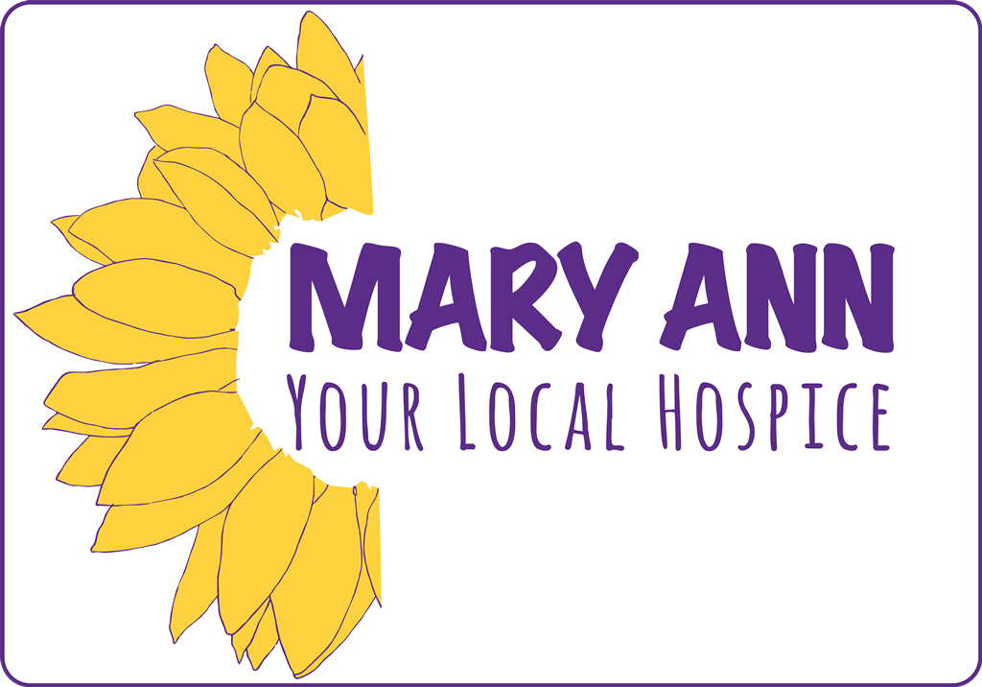

**STATEMENT OF PURPOSE**

**June 2023**

Mary Ann Evans Hospice, Eliot Way, Nuneaton, CV10 7QL Tel: 0224 76865440

Email: [maehenquiries@geh.nhs.uk](mailto:maehenquiries@geh.nhs.uk) Website: <http://www.maryannevans.org.uk>

Charity Number: 1014800 Registered in England Number: 02750734 Company Limited by Guarantee

**Contents**

|  |  |
| --- | --- |
| Provider Information | 3 |
| Mission Statement | 4 |
| Vision | 4 |
| Values | 4 |
| Services Provided by the Mary Ann Evans Hospice | 5 |
| Referral Criteria | 7 |
| Support and Appraisal | 7 |
| Activities of the Team | 8 |
| Volunteers | 8 |
| Our Staff | 10 |
| Governance | 11 |
| Patient and Family Viewpoint | 11 |
| Organisational Chart | 12 |
| Governance Structure | 13 |
| Comments, Compliments and Complaints | 14 |

**Provider Information**

**Registered Provider**

Mary Ann Evans Hospice

Eliot Way

George Eliot Hospital Site

Nuneaton

CV10 7QL

Tel: 024 76865440

Fax: 024 76865438

Email: maehenquiries@geh.nhs.uk

Website: www.maryannevans.co.uk

**Responsible Individual**

Chief Executive - Mrs Elizabeth Hancock

* CMI Level 7 Diploma in Strategic Management & Leadership (QCF)
* Over 25 years’ experience of leadership in hospice services
* Chair of Healthwatch Warwickshire
* West Midlands’ Regional Representative for the Advisory Council of Hospice UK
* Chair of Governors at a local school

**Registered Manager**

Director of Clinical Services - Mrs Esther Reilly

* MSc in Health and Care System Leadership, CMI Level 7 Senior Leaders Master’s degree- Chartered Manager status (CMgr FCMI)
* BSc (Hons) in clinical Nursing (oncology), Registered Nurse.
* 25 years’ clinical experience in oncology and palliative care with 8 years of clinical hospice experience.

#### Mary Ann Evans is registered with the Care Quality Commission (CQC) www.cqc.org.uk) for:

#### Regulated activities

#### Treatment of disease, disorder or injury

#### Specialisms/services

* Caring for adults under 65 yrs
* Caring for adults over 65 yrs

**Mary Ann Evans Hospice (Mary Ann)**

**Statement of Purpose**

**The Mary Ann Evans Hospice is** a Warwickshire Adult Hospice, caring mainly for patients who live in the north of the county, but also some patients from South Leicestershire, the East of Birmingham and Coventry. As an independent charity we provide clinical, nursing, care and support to patients, with cancer and other life limiting illnesses, and their families.

We work closely with our community and hospital colleagues from the NHS, Social Services, local Care Homes and other voluntary providers.

Our care is unconditional, non-judgemental and provided free of charge to, regardless of creed, ethnic origin or social background.

**Mission Statement**

* *Mary Ann Evans Hospice will provide comprehensive, high quality support and end of life care across our community through all the services we provide to patients and those close to them.*
* *We will do this in partnership with others where appropriate*
* *We are committed to training, supporting and encouraging our staff and volunteers to achieve our mission.*

**Our Vision Statement is:**

*Patients, families and carers in our community experience a journey towards the end of life and into bereavement that is personalised, supported, comfortable, safe and is in a place of their choice.*

**The Mary Ann Evans Hospice cares about:**

* **PEOPLE –** Patients, families, staff, volunteers, our community and our professional colleagues
* **QUALITY -** We strive for excellence in everything we do
* **FAIRNESS –** We believe in equity of treatment and will be non-judgemental of others. We will not accept discrimination in any form
* **TEAMS –** We will recognise that we are a multi team organisation and everyone has a key role in the success of ourmission. We will have respect for each other and will manage differences of opinion
* **PROFESSIONALISM –** We will respect the professionalism of our colleagues and will ensure we maintain our professional standards and qualifications
* **ENVIRONMENT –** We will strive to provide the best possible environment for our patients and families and working conditions for staff and volunteers. We will try to be eco-friendly

**Services Provided by the Mary Ann Evans Hospice**

**Day Services**

Day services aims to promote independence, maintain function and manage complex clinical problems, to help patients live well for as long as possible. Staff can help to address problems with symptom management and the physical, psychological and emotional issues associated with a life limiting illness, as well as provide support and guidance with financial or social concerns and spiritual care. The support is either offered through our virtual programme delivered via video calls or in face to face groups Monday to Friday. Support is also offered to carers though telephone, video or face to face sessions.

**Hospice at Home**

The Hospice at Home team provides services directly into the patient’s own home every day of the year, helping people remain in their home surrounded by those who are important to them.

The team comprises of Senior Care Support Workers and Staff Nurses all of whom are experienced and specially trained to provide high quality, compassionate, evidence based practical nursing care and support in the later stages of life. The Hospice at Home team work closely with community and hospital palliative nurse specialists, district nurses and GPs, helping and supporting as illness advances, especially as the illness reaches its final stages and the final wish is to stay at home.

We also provide respite care both the day and overnight within service availability providing a much need break for family carers. The team also offer support visits to establish relationships with patients and families, provide carer support which helps us identify early needs for increased care as an illness progresses.

**Rapid Response End of Life Team**

Working in partnership with the South Warwickshire Foundation Trust (SWFT), Mary Ann Evans Hospice assists in providing a continuous and blended end of life community nursing and hospice at home service across a 24-hour timeframe for people, across Northern Warwickshire and surrounding areas, for those people living with a life limiting illness. The aim is to respond with a home visit, within 2 hours, to any calls for help as determined by agreed criteria for service response. This allows us to maintain dying people in their own home/usual place of residence and to support discharge from A&E before admission, if the individual is clinically fit for discharge, or prefers to return home with intermittent support as clinically necessary.

A pilot day Rapid Response service started in July 2019 and further development took place during 2020, however COVID-19 impacted on the severity of this development due to increasing needs of the service due to COVID-19. However, as a team Rapid Response continue to develop. By having Rapid Response in the day, it allowed the service to provide a full 24-hour, 7 days a week service for those who are palliative/ end of life who wished to stay in the comfort of their preferred place of care in the community.

**Lymphoedema Service**

This specialist service is available to patients with cancer related oedema living in Northern Warwickshire and surrounding areas. The service is provided in a purpose built clinic within the Hospice or, occasionally in patients’ own home, by our Lymphoedema Nurse Specialist or the Lymphoedema Assistant Practitioners. The service assesses and treats mild to complex cases of lymphoedema with the objective of reducing and maintaining levels of swelling. The service provides an advisory telephone service which further contributes to the objective of enabling patients to self-manage this long term condition.

**Complementary Therapies**

We offer a range of complementary therapies which can be received safely alongside your current medical care. They are carried out by our team of experienced and qualified therapists. We offer a range of therapies including therapeutic massage, aromatherapy, reflexology, Indian head massage and reiki all customised to support the needs of our patients and their carer's. Complementary therapies may help to promote relaxation, reduce stress and anxiety, assist with emotional support and resilience, help to manage pain and discomfort, encourage better quality sleep and balance energy levels.

**Spiritual Care**

At Mary Ann we recognise that spiritual care is an important part of end of life care and can help patients and their families find meaning, comfort and strength during difficult times. Spiritual support is offered to all patients and their families from staff and from our close connections with multi faith religious leaders in the George Eliot Hospital Chaplaincy team.

**Family Support and Bereavement Services**

Our Family Support service offers emotional support to people approaching end of life and their families plus bereavement support after the death. During such difficult times people can find a lot of value in talking to our team (staff and volunteers) who provide an independent, safe space to discuss how they feel with someone not connected to the situation. Individual support is available via face to face, telephone or online video 1:1 appointments. Group support sessions are also available and offer a chance to meet and learn from others going through similarly difficult times whilst also receiving tailored education and support for you. Additionally, our children’s service provides emotional support for children and young people between the ages of 5 – 18 who have a family member dying or have been recently bereaved. **Referrals**

Criteria for Accepting Referrals

The Mary Ann Evans Hospice care is predominantly available for people who reside in the Nuneaton, Bedworth and North Warwickshire area and/or are registered to a Warwickshire North Clinical Commissioning Group GP.

Each patient accepted for Mary Ann’s services (with the exception of lymphoedema) will meet the services referral criteria of having a life limiting illness and will most likely be approaching their last year of life.

Referrals are accepted from any professionals involved in your care – for example district nurse, GP, Macmillan nurse. Family members can refer to our services as long as the patient and the registered GP agree.

Procedure for Referrals

Referrals for the community and day services will be made using the Mary Ann’s Clinical Service Referral form and will conform to the minimum data set.

The Referral Form must be completed in full, with contact details to elicit further information if required.

The patient’s general practitioner will be made aware of the referral and the patient must have consented to the referral.

Additionally, Mary Ann will accept self-referrals once the patient’s general practitioner confirms the clinical history.

Referrals for the Family support and Bereavement service can be made by telephone to 024 7686 5431and can be made by the person themselves, a family member or professional involved in their care with the person’s permission.

Support and Appraisal

All staff will have an annual appraisal by their line manager and their continuing professional development will be identified within this process.

All staff are required to take part in annual mandatory training as required by Mary Ann e.g. Moving and Handling, Fire training, Infection Control, Safeguarding etc.

Opportunities will be provided for educational sessions and staff will be encouraged to continually update their knowledge.

All staff will have a period of induction and a mentor appointed for a minimum period of 6 months.

Depending on the area of work staff will be supported to maintain their physical and emotional well-being. This may be through coaching, supervision and team meetings alongside line management meetings.

All clinical staff will demonstrate a willingness to undertake appropriate study in the field of palliative and end of life care at a level appropriate to their role. Staff working in other areas of the hospice will be encouraged to develop their skills and experience in their area of work.

Activities of the Team – Patient Care

The team will meet every week to discuss the ongoing management of patients as needed. Our clinical staff will keep up to date with current treatments and new developments utilising this knowledge when assessing patients and planning their care with them.

Staff will encourage and enable patients to be independent within the limitations of their illness. Where necessary, with patients consent an advocacy service will be offered.

We may refer patients to other disciplines and agencies, which are not represented on the staff, but have the skills and knowledge to improve the patient’s overall well-being e.g. Speech Therapy.

Equipment that aids the comfort of the patients and enables the nurses to maintain the high standards of safe and effective care will be used in conjunction with Health and Safety requirements.

Staff will attempt to answer all questions honestly, giving opportunity for patients to talk about their fears, anxieties and problems.

Staff will be prepared to respond to anticipatory grief and spiritual issues appropriately as and when they arise, to meet the patient’s needs. Spiritual leaders from all faiths and denominations are welcome and will be contacted at the patient’s request.

Staff will be available to offer support/advice to families/carers, whilst always being aware of patient confidentiality.

Student doctors, nurses and other allied health personnel also have placements within the Day Hospice.

**Volunteers**

The Mary Ann Evans Hospice is heavily dependent on the commitment and skills of over 250 volunteers, providing support to patient services, income generation, bereavement support and our charity shops. Not only do they provide an essential service at limited cost to Mary Ann but also form an important link with the community.

Volunteers perform duties such as meal preparation, driving patients, giving support in the Day services and assisting with our Family Support & Bereavement Service. In addition volunteers also contribute to our work in administration, income generation, facilities and our shops.

**Our Teams**

**Clinical Services**

Mary Ann employs, in order to provide an effective, flexible and bespoke service, a mixture of Staff Nurses and Senior Care Support Workers. The team are supported by complementary therapists and the cook ensures nutritional meals are available.

**Family Support & Bereavement Services**

The team employ counsellors and a psychologist and are further supported by a team of trained volunteers.

**Administration, Finance & Payroll**

We have a team of staff to support the business functions of the organisation which include administration, finance, human resources and payroll

**Facilities**

Mary Ann has a small team of staff to maintain the buildings including a caretaker and housekeeping staff.

**Income Generation**

Our team consist of staff working in our retail, grants and trusts and income generation team. This is alongside our digital and website staff member.

**Volunteers**

Volunteers play a large part in supporting the work of the hospice across all teams including clinical services. Volunteers are trained and supported as part of their role.

All our staff have qualifications, professional membership and the relevant experience to carry out their professional roles. They are expected to participate in our in‐house training and development programme and to attend relevant external training courses.

**Governance**

The Mary Ann Evans Hospice is a registered charity (no. 1014800), managed by a group of 9 trustees. Mary Ann’s Board of Trustees meet formally, every two months, to attend to governance issues and in smaller subcommittee group meetings to progress issues of importance to Mary Ann.

Working alongside the Chief Executive and Leadership Team, the Trustees ensure the maintenance of quality standards, financial viability and clinical governance of Mary Ann.

**Patient and Family Viewpoint**

At the Mary Ann Evans Hospice we welcome the viewpoint of all our services users. We believe that we can take valued guidance from those who have experienced our services and also from those who work alongside our service. There is a suggestion/comment box in Mary Ann’s Reception area and a comments book in our Lymphoedema clinic area. Our Chief Executive and Director of Clinical Services will monitor all comments and they are then presented to the Board of Trustees.

Feedback is welcomed and encouraged all through the year, and to demonstrate our commitment to providing opportunities for real-time monitoring we use iWantGreatCare for all clinical services with the exception of the Family Support and Bereavement service which has a bespoke feedback mechanism given to all users of the service. Real-time monitoring is consistent with the requirements of the fundamental standards of care and enables staff to take immediate action to address any issues raised, at the time.

On a biennial basis, through Birdsong, staff and volunteer surveys and questionnaires are carried out. If required one-off surveys will also be carried out.



Organisational Chart

**Governance Structure**

**Board of Trustees**

Mr C Bartup (Chair)

Prof S Dibb (Vice Chair)

Mr J Barrett

Ms R Dollen

Ms S Darby

Mrs K Fawcett

Dr P Handslip

Mrs M Hawkins

Mrs H Norgrove

Mr D Phimister

Mr RP Robson

Mr T Storrow

Mrs J Town

**Leadership Team**

Elizabeth Hancock – Chief Executive

Esther Reilly – Director of Clinical Services

Philippa Graham – Associate Director of People Development & Education

Lisa Perrins – Head of Clinical Services

Miss J Daly – Head of Marketing and Income Generation

**Sub-Committees**

**There are four subcommittees:**

* Business
* Clinical Governance
* MAGIC (Marketing, Communication and Income Generation)
* People

Page 13 of 14

**Comments, Compliments and Complaints**

It is the policy of the Mary Ann Evans Hospice to welcome comment about our services whether positive or negative. It allows us to constantly monitor and update the quality of our services. Early action can go a long way in preventing more formal complaints, resulting in problems.

If you have reason to comment or complain about any aspect of the services provided by the Mary Ann Evans Hospice, please ask a member of staff for advice. They will direct you either to the Suggestion Box or our Complaints procedure.

Complaints may be made verbally to any member of staff, or in writing. They may be formal or informal. Mary Ann provides education to promote good communication skills and understanding of how to receive a complaint.

Written details of both verbal and written complaints must be recorded on the Complaint Form and given to the Director of Clinical Services or the Chief Executive.

**Patients, or Families may also refer unresolved complaints to:**

The Parliamentary health ombudsman  [www.ombudsman.org.uk](http://www.ombudsman.org.uk)

The role of the ombudsman is to consider complaints that organisations have not acted properly or fairly or have provided a poor service. It covers many organisations including the NHS and charities like hospices where health care is part funded through the NHS. The local Healthwatch can also provide support in complaint resolution. <https://www.healthwatchwarwickshire.co.uk/>

Our Inspecting Body is:

**Care Quality Commission**

**CQC West Midlands**

**Citygate**

**Gallowgate**

**Newcastle upon Tyne**

**NE1 4PA**

Telephone: 03000 616161

Email: central@cqc.org.uk

Provider ID: 1-149412644